**Objecting to a 9013 Motion**

(Basic instructions for unrepresented parties for the “if objection” process)

This overview is provided to help parties who do not have a lawyer understand and participate in the 9013 “if objection” motion process. This is not a substitute for the official rules or procedures.

**What is Rule 9013?**

The 9013 “if objection” motion process officially refers to Local Rule 9013-1. This is referred to as the “if objection” process because a hearing will only be held IF there is an OBJECTION.

A debtor or creditor in a case can file motions with the Court. Think of a motion as a request for the Court to approve something a party wants. These motions may be good for the requesting party but can negatively affect your rights.

If you have received a motion in the mail and you do not want it to be approved or if you want the Court to consider your position on the matter, you MUST file an objection with the court.

If no objections are filed by the end of the deadline, the Court will not hold a hearing and will approve the motion.

The motion you received should have 3 main parts.

* 1. A notice on the first page with a deadline for filing an objection and when the court hearing would be held IF THERE IS AN OBJECTION FILED. If no objection is filed, THERE WILL NOT BE A HEARING.
  2. When the notice section is finished, there should be a description of the motion and an explanation of what is being requested and why.
  3. A copy of a “proposed order.” If no one objects, this is what the Court will be approving.

The Motion you received will have a deadline at the top of the page. You must file your objection by this date. This date is shown in Green in the example below. (the actual notice will not be in color)

If there is an objection filed, the court will hold a hearing on the date, time, and place in Blue in the example below.

The items in Red in the example below show case information and what the motion is about.

The Black text shown in the example below is the standard form of the “if objection” notice.

**How do you object?**

If you decide you want to object to a motion, you need to prepare a written objection. Your objection must include:

* 1. The case number, debtor’s name(s), and judge (from the notice)
  2. The deadline for filing an objection to the motion (from the notice)
  3. The date, time, location, and courtroom of the scheduled hearing (from the notice)
  4. The name and contents of the motion you are objecting to (from the notice)

Your objection can be filed electronically, by mail, or by hand delivery to the Court Clerk’s Office at 701 Broadway, Room 170, Nashville, TN 37203.

Once you have filed your objection with the Court Clerk, the Court will normally hold a hearing on the date and time listed on the notice and motion. This will be your chance to address the Court with your objection or concerns.

Questions? You may want to consult with an attorney to evaluate your rights in the case. The Court Clerk’s office is legally prohibited from providing legal advice to any party in a case. However, it can answer procedural questions and can sometimes help get your objection filed with the Court. You can contact the Clerk’s Office at 615-736-5584.

**Example of a Notice and Motion**

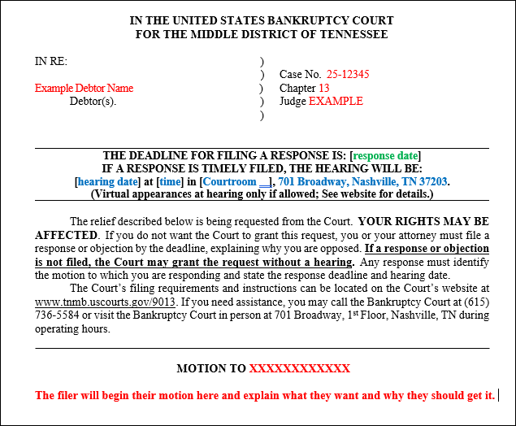

Example Objection

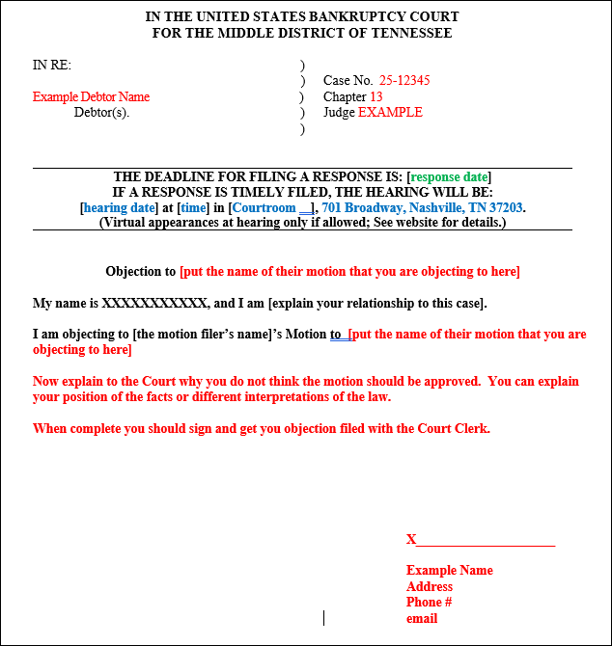

Tips:

* Don’t wait until the last minute to file your objection. If you don’t get it filed by the deadline, it may not be considered by the judge.
* The court is aware you are not a lawyer, you do not have to talk like one. Just clearly explain why you are objecting to the motion in plain language.
* The Court Clerk’s office can’t give legal advice or tell you what to do, but they can answer some procedural questions.